
Homework Menu
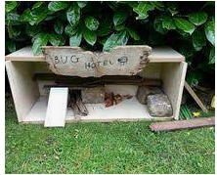
Summer 1
FS1 Nursery
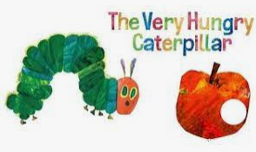
How does your garden grow?

In FS1 we learn mainly through play and we would love to see the play activities you do at home.
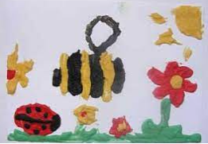
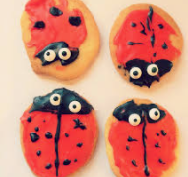
We are going to set some challenges for your child to do and we would like you to upload these to Dojo, or you can bring them in to school. Try to do at least 5 of the set challenges and 2 of your own such as learning to ride a bike, learning to swim or helping around the house.
- Go on a hunt around your garden or the local park. What can you see?
- Paint a picture of your favourite mini beast.
- Use a paintbrush and water or use chalk to write your name outside.
- Make a mini beast house.
- Make a flower with 5 petals on it. Can you write the numbers 12345?
- Read the book the hungry caterpillar and write a list of your favourite foods to eat.
- Make a ladybird biscuit.
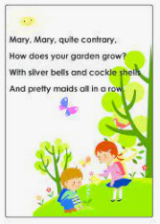
- Plant a seed and watch it grow. Take pictures and talk about the changes you see.
- Find the tallest and shortest thing in your outside area.
- Try a fruit or vegetable that you have not tasted before.
- Sing the nursery rhyme Mary, Mary quite contrary.
- Move like a minibeast: Crawl like an ant, fly like a butterfly, slither like a snail, spin like a spider

Together, we can achieve anything!

