
Year 3 Spring Term 1 Newsletter

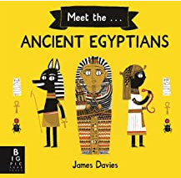
English
This half term we are going to be looking at the texts ‘There’s a Pharaoh in Our Bath’ and ‘Meet the Ancient Egyptians’ which link to our humanities topic ‘Ancient Egyptians’. The children will be continuing to look at using accurate punctuation within their writing. We will be looking at diary entries, story writing and poetry to express emotions.
Maths
In maths, we will be continuing to focus on multiplication and division and then move onto money and statistics. Please continue to learn your times tables at home.
Humanities
Our topic this term we will be learning about the achievements of Egyptians in the reign of King Tut. We will be looking at life in ancient Egyptian times and learning about the life and death of Pharaoh’s during this period.
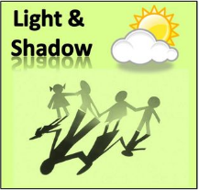
Science
This half term, we will be learning about ‘Light and Shadow’. The children will be investigating different sources of light, how light is reflected, night and day as well as shadows and how they are formed.
PE
PE is on a Tuesday and Thursday. Could you please ensure the children have warm clothing for the Thursday session as this will be taking place outside whenever the weather is suitable. We are looking at Gymnastics and Handball. The children must make sure that they have suitable PE wear with them on both these days.
Spellings
Children will receive their spellings every Friday and will be tested the following Friday. Children who get 8, 9 or 10 spellings will receive a full merit. The child will be told their score before their next spelling test. We have tested the children on their spellings in class and from these assessments we have given the children spellings which they are not always spelling accurately. The children need to not only spell the words correctly in the test but also within their writing. We thank you for your help and support with this as it is an area which we are targeting.
Achievement Award
This half term our achievement award target is focused on tidiness. This will include ensuring our work is tidy and well-presented and that our own learning areas and equipment are kept tidy and organised.
Attendance

We will be continuing to improve on the attendance and hope that your children come to school every day as this helps with their learning. Please also try and make sure that they arrive on time at 8:45 am and are picked up at the end of the school day.

Home and School Relationship
Please make sure your child brings in a water bottle each day. It is also useful to have your child’s name on their clothing. Those children who are reading at home are making a lot of progress in school which is fantastic. We do look through your child’s reading book to check that they are reading at home. Please could either you or your child make a note in their diary when you have read. We are thankful for all the support you give us in school. Please continue to come and see one of the team with any worries or concerns at the end of the day. We also thank you for the hard work that you are putting in at home for the children’s homework. We do really appreciate all of your hard work and efforts and it is gratefully received in class.

Dates for the Diary
1950’s dress up day and special lunch is Thursday 20th January.
We break up for February half term on Friday 11th February.
Thank you for your continued support
Mrs Gibson, Mrs Wilkinson and Mrs Lawlor
Together, we can achieve anything!

