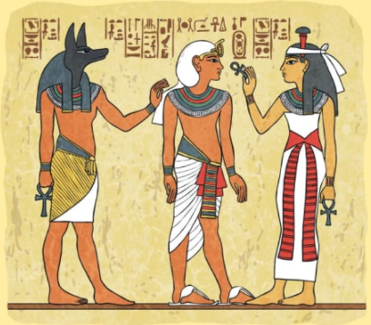
Ancient Egyptians – Homework
Spring Term 1st Half
40 Points
- Research and write a fact file about an Egyptian Pharaoh
- Create an Egyptian costume for a Pharaoh.
- Write a story about an adventure in Ancient Egypt.
5 Points
- Make a list of facts about Ancient Egypt.
- Create a postcard all about Egypt.
- Draw a picture of an Egyptian landscape.

10 Points
- Research hieroglyphics and spell out your own name.
- Draw a picture of an Ancient Egyptian Pharaoh.
- Research shadow puppets and have a go at making your own.
20 Points
- Draw/trace a map of the world labelling the Egypt, the Nile and the pyramids.
- Research and write a fact file about an Egyptian Pharaoh
- Create an Egyptian costume for a Pharaoh.
- Design your own Death mask.
Compulsory Activities
- Reading 3 times a week.
- To practice 2,5,10,3 and 4 times tables
- Learn weekly spellings.

This term we will be asking the children to choose the homework which they would like to do from the homework menu below. The ones in green need to be completed but the other activities the children can choose from. The children need to complete activities which total to 100 points. In addition to this, each week we will also be sending home either a piece of English or Maths homework that should be completed for the following week.

