Model of a building  Choose a building from our local area and create a model.  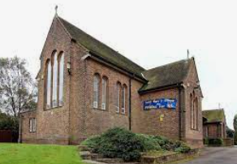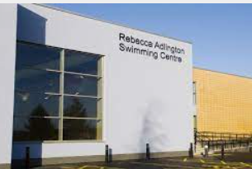 | Journey to School 20 points  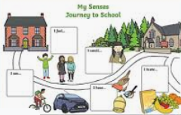  Draw or create a 3D map of your journey to school.  Label your map. | Favourite Story 20 points    Choose your favourite story. Read it with an adult.  Draw a picture and write a sentence about the story.
Name writing 20 points  Write your first and surname.  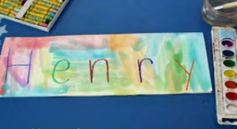  Be creative use different colours and writing tools. | Homework Challenge  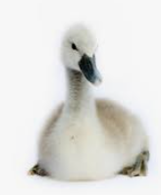  Autumn1  Year 1  Me and my local area | My 5 Senses 20 points  In your home and garden make a list of different objects that you can hear, smell, feel, taste and see. 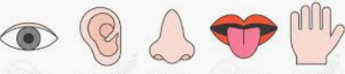
Measuring 20 points  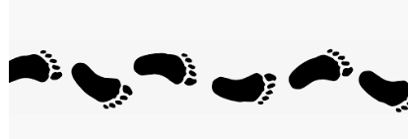  Use your footsteps or strides to meassure the length of different rooms in your house. | My body 20 points  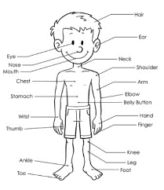  Create a picture of a person and label parts of the body. | All about me 20 points  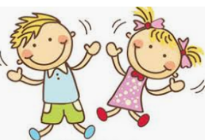  Make a fact file all about yourself.  For example, your name, favourite colour, favourite TV show, what you enjoy doing, the colour of your hair.
To complete many of these activities you will need an adult to help you.
Choose from the above activities. You are expected to score 100 points (5 activities) or more.
Please return all completed tasks before Friday 13th October.

