Model Space Craft 20 points  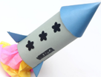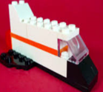  Make your own space craft.  It could be a rocket, moon buggy or shuttle.  You can make the model out of old boxes, Lego or other materials.  For an extra 10 points draw and label your model. | Number Blast 20 points  Count forwards and backwards 0-20  Record the numerals in a number line.  Count forwards and backwards in 10’s  Record in a number line.  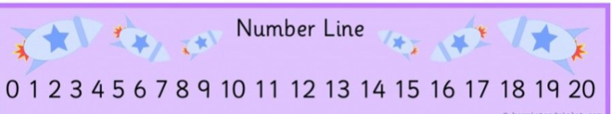  For an extra 10 points  Count in 5’s up to 100. | Space Story 20 points  Visit the Library  Choose a space themed story to share with an adult.  Draw the front cover of the book.  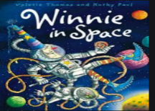  For an extra 20 points Write a book review.
2d Space Picture 20 points  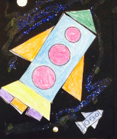  Using 2d shapes such as squares, circles, triangles and rectangles. Create a space themed picture.  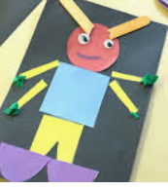 | Year 1 Cygnet Class  Space  Homework Challenge  . | Alien Cakes 20 points  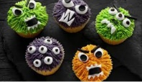  Bake a cake and decorate it to look like an alien. Take a photo of your creation.  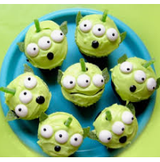
Space Snap 20 points  Make a space themed snap game.  Make two sets of words with space themed words on such as, rocket, zoom, blast.  Now play snap with a family member.  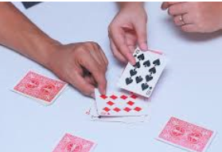 | Make a List 20 points  Imagine you are a spaceman. What things would you pack for your space journey?  Write a list of the items.  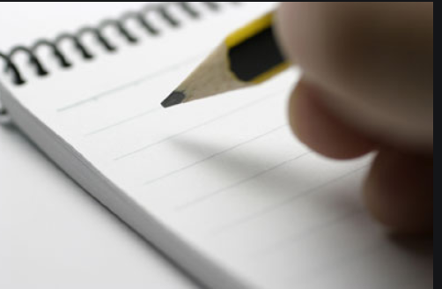 | Night Sky 20 points  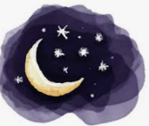  Look at the night sky  What did you see?  What did you hear?  Did you see any stars?  Can you see the moon?  Create a picture or write about what you could see and hear.
To complete many of these activities you will need an adult to help you.
Choose from the above activities. Look at the score points for each task, you are expected to score 100 points or more.
Please return challenges on or before Thursday 14th December.

