

Schools must use the funding to make additional and sustainable improvements to the quality of PE and sport they offer. This means that you should use the Primary PE and Sport Premium to:

- develop or add to the PE and sport activities that your school already offers
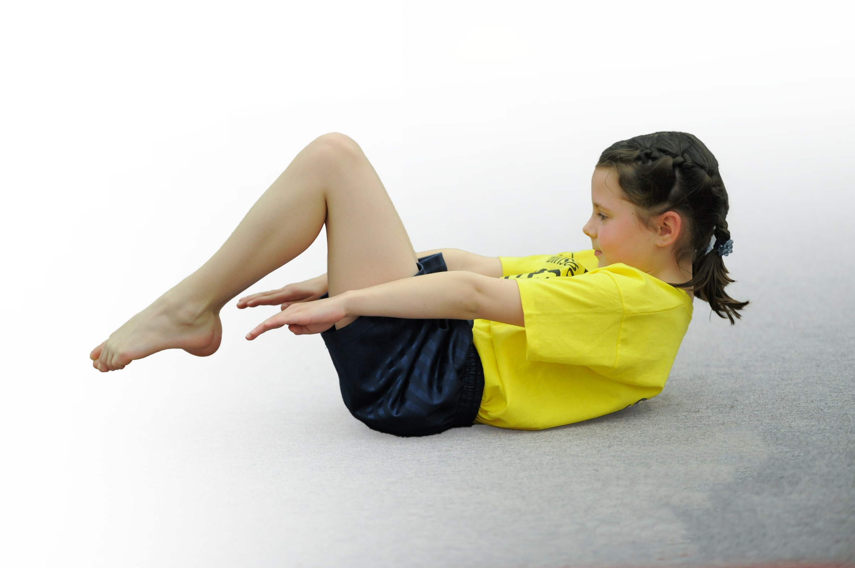
- build capacity and capability within the school to ensure that improvements made now will benefit pupils joining the school in future years

Please visit gov.uk for the revised DfE guidance including the 5 key indicators across which schools should demonstrate an improvement. This document will help you to review your provision and to report your spend. DfE encourages schools to use this template as an effective way of meeting the reporting requirements of the Primary PE and Sport Premium.

We recommend you start by reflecting on the impact of current provision and reviewing the previous spend.
Under the Ofsted Schools Inspection Framework, inspectors will assess how effectively leaders use
the Primary PE and Sport Premium and measure its impact on outcomes for pupils, and how effectively governors hold them to account
for this.

Schools are required to publish details of how they spend this funding as well as on the impact it has on pupils’ PE
and sport participation and attainment.
We recommend regularly updating the table and
publishing it on your website as evidence
of your ongoing review into how you are using the money
to secure maximum, sustainable impact. To see an example of how to complete the table please click HERE.

Support for review and reflection - considering the 5 key indicators from DfE, what development needs are a priority for your setting and your students now and why? Use the space below to reflect on previous spend, identify current need and priorities for the future.

Key achievements to date: | Areas for further improvement and baseline evidence of need:
School Games Bronze  Booster swimming sessions introduced for Years 4, 5 and 6  All children have 2 hours timetabled PE sessions a week  In Summer 2019 66 % of children were involved in extracurricular sporting activities | Develop Whole School Daily Physical Challenge  For children to reach the Government recommendation of the 60 minutes of daily physical activity. 30minutes during the school day and encourage and develop opportunities for 30 minutes outside the school day.

Meeting national curriculum requirements for swimming and water safety | Please complete all of the below*:
What percentage of your current Year 6 cohort swim competently, confidently and proficiently over a distance of at least 25 metres? | % 45%
What percentage of your current Year 6 cohort use a range of strokes effectively [for example, front crawl, backstroke and breaststroke]? | % 28%
What percentage of your current Year 6 cohort perform safe self-rescue in different water-based situations? | % 35%
Schools can choose to use the Primary PE and Sport Premium to provide additional provision for swimming but this must be for activity over and above the national curriculum requirements. Have you used it in this way? | Yes/No £2,000 for summer intensive booster sessions for those year 4 and 5 children unable to swim 25meters.
*Schools may wish to provide this information in April, just before the publication deadline.

Action Plan and Budget Tracking
Capture your intended annual spend against the 5 key indicators. Clarify the success criteria and evidence of impact that you intend to measure to evaluate for students today and for the future.

Academic Year: 2018/19 | Total fund allocated: £12.975 | Date Updated: 10th December 2018
Key indicator 1: The engagement of all pupils in regular physical activity – Chief Medical Officer guidelines recommend that primary school children undertake at least 30 minutes of physical activity a day in school |  |  |  | Percentage of total allocation:
 |  |  |  | 60%
School focus with clarity on intended impact on pupils: | Actions to achieve: | Funding allocated: | Evidence and impact: | Sustainability and suggested next steps:
Active start club- to encourage more pupils to attend school earlier and get involved in physical activity.  Invest in playtime equipment – whole school  Skip2Bfit day  Whole school daily challenge  Training Sports Crew  Midday training  Active 30 minutes  Active Lessons | 2 members of staff to prepare food and supervise physical activities.  Pupil questionnaires’- school council. Audit equipment e.g. bats balls quoits, beanbags.  Introduce skipping challenge with whole school skipping challenge with Skip2Bfit .  Children to all be involved in daily 2 minutes daily skipping challenge  A TA to take 8 Year 5 and 6 pupils to West Notts College for Sports crew training provided by School Games (22.1.19)  Transport to venue  MDSA,s trained by Next Level Sport to encourage children to be more active during Lunchtimes  Staff training  LS to deliver staff meeting to feedback from Active minutes’ course  Increase active lessons  Outdoor learning days/ No chair days/ staff swaps | £11,325  £ 500  £750  £200  £200  £0  £0 | 40 children attend Active start club many are PP children.  Children more active during break times, playing cooperatively.  More pupils involved in skipping new skill. Everybody active towards the 30 minutes daily physical activity.  Year 5 and 6 children trained to lead activities.1focused activity / challenge a day.  Children are more active at lunchtimes. MDSA engaged with pupils.  All classes to be using a physical starter  All children involved in active lessons starters every day.  Foundation Stage and Key Stage 1 flagship for active learning.  KS2 developing | After April, this is unsustainable due to the high cost of staffing.  Playground monitors to check on equipment develop sports crew training spring term .  School daily challenge  2 minutes skipping every day for every year group.  This will last all Year.  Year 5 pupils to continue when Year 6 pupils move onto secondary school.  Continue to monitor MDSA training needs and retrain if necessary.  Monitor / Learning walks  Monitor / Learning walks  Lesson Studies
Key indicator 2: The profile of PE and sport being raised across the school as a tool for whole school improvement |  |  |  | Percentage of total allocation
 |  |  |  | 0.5%
School focus with clarity on intended impact on pupils: | Actions to achieve: | Funding allocated: | Evidence and impact: | Sustainability and suggested next steps:
Sport Themed assemblies  Termly newsletter  Termly Governors report  Notice Board  Health and Wellbeing day | LS PE coordinator to provide sports themed assemblies every half term.  Certificate’s to celebrate in school sporting achievements used as part of weekly Super kids celebration assembly.  Sporting Newsletters sent home termly, also posted on  Facebook and Website  PE Coordinator to inform School Governors how the PE premium money is being spent.  Hall notice board showing PE though the school and corridor notice board for events/ competitions/ challenges/ club links.  LS and SM (PE and PHSE coordinators) to arrange a whole school Health and wellbeing day incorporating PHSE and PE. | £0  £10 printing costs  £0  £10  £100 | Celebrating sporting achievements  Raise profile of PE  Ensure parents know the range of sporting activities/ events in school.  Governors aware  PE specialist Governor to be fully informed. Set up meeting with PE coordinator.  Parents/ children to see notice boards  All pupils to have a better understanding/ knowledge of how to stay fit and healthy. | Time tabled assemblies  Certificates for children.  Embed this as practice.  LS PE coordinator to deliver report in FGB  Refresh and update when needed.  Plan a health and wellbeing day yearly

Key indicator 3: Increased confidence, knowledge and skills of all staff in teaching PE and sport |  |  |  | Percentage of total allocation:
 |  |  |  | 2.5%
School focus with clarity on intended  impact on pupils: | Actions to achieve: | Funding  allocated: | Evidence and impact: | Sustainability and suggested  next steps:
To be aware of currant inisatives from the government regarding PE Sports Premium allocation.  Staff CPD including Sport coach observation/ Sport partnership meetings/ SG training courses/ Collaboration links.  Children more active in PE lessons and Maths lessons.  To carry out Staff PE Skills audit  To introduce children to new sports  To develop teacher and TA confidence delivering new sports/ PE sessions.  To develop a bank of lessons plans | 27th November  LS JF (PE coordinator/ Head Teacher attend Sports Conference  31st January manor Math s of the day Maths Coordinators LG/KS to attend and feed back in staff meeting.  4th April KS1 and KS2 Leaders delivering PE LB/SB  SGP termly meetings  19.9.18 , 4.3.19, July 2019  Carry out staff and TA PE skills audit to address gaps and training needs.  Cyber Coach to support delivery of Active starters and dance sessions  Following coaching sessions staff to produce own set of lesson plans to support future lessons | Partnership membership £500  £0  £295  Part of Key indicator 4 spending | Increased knowledge and confidence all staff.  Staff attending training courses to feed back to staff though Staff meetings and Key stage meeting.  Address gaps and inform 2019/2020 action plan.  More confidence supporting delivery of active starters and dance sessions  Lesson plans notes to be monitored by PE coordinator | Part of school games partnership offer continue to be a member of the partnership.  Gaps addressed on 2019/2020 action plan training needs.  Renew/ review membership./ license.  Monitoring feed back
Key indicator 4: Broader experience of a range of sports and activities offered to all pupils |  |  |  | Percentage of total allocation:
 |  |  |  | 28%
School focus with clarity on intended  impact on pupils: | Actions to achieve: | Funding  allocated: | Evidence and impact: | Sustainability and suggested  next steps:
Additional achievements:  To introduce children to new sports  Though in school coaches as part of PE sessions.  New equipment to support new sports.  As part of after school offers coaches and staff used to run after school clubs. | Long term plan used to introduce new sports which can be delivered by coaches or class teachers depending on need.  In school coaches to be used to deliver a 6 week block of lessons for the following sports  Yoga, tri golf, mini kicks, basketball, dance, football, boccia, kurling, handball and squash.  Staff to deliver new sports  Including badminton, rounder’s, multi skill, netball. Yoga KS1 Foundation using cosmic kids as support. gymnastics using Val Sabin file as support.  Audit equipment in line with long term plan .  Refresh old broken equipment.  Coaches booked for after school sessions.  Afterschool clubs to include  Rudby, Basketball, Football, Dance, Netball, Multi skills 5/60 club, Boccia, | £5.500  £500 | Staff able to create own lesson plans following coach sessions.  Children introduced to new sports and out of school club links.  Club flyers, posters distributed news on newsletter, webpage and face book for links.  Staff use knowledge gained from previous coach sessions and strengths to plan and deliver lessons. Lesson plans audit.  Club links developed for children to take up sports outside of school  Children have the correct and safe equipment during PE sessions  More children involved in afterschool activity contributing to the 60 active minutes.  Club links developed for children to take up sports outside of school | Staff questionnaires to address gaps for future planning.  Coach bookings for 2019/2012 depending on funding  Funding dependent for 2019/2020.  Continue to audit and monitor  Funding dependent for 2019/2020.
Key indicator 5: Increased participation in competitive sport |  |  |  | Percentage of total allocation:
 |  |  |  | 6.5%
School focus with clarity on intended  impact on pupils: | Actions to achieve: | Funding  allocated: | Evidence and impact: | Sustainability and suggested  next steps:
All children to be involved in competitive games/ competition.  To develop school Intra games  For pupils to represent the school in competitive games.  All children to take part in individual challenge  Traditional sports day  All children take part in a team multi skills competition (potted sports day) | Following a block of PE lesson coach sessions children to take part in house competitions between year groups.  Events to include football, basketball, handball and rounder’s.  Children selected depending on SG criteria to represent the school in a variety of sporting events.  Events to include  Autumn term  Multi skills 4.12.18 Year 3,4,5,6,  Spring term  27.2.19 Badminton year 4/5  12.3.18 Multi skills year 4,5,6  Summer term  24.4.19 Football year 3, 4 boys  20.5.19 Boccia year 5/6  18.6.19 Orienteering Year 5/6 girls  8.7.19 Rounder’s year 4/5  Annual Intake sports day  Sports Crew to develop skills by being leaders  Year 6 to lead this multi-skills challenge day | £ 0  (part of the indicator 4 funding)  Transport costs  £1,400  £10 reward stickers  £10 reward stickers | Improved standards of competitive games. All key stage 1 and 12 children to be involved in at least one in house competitive competition.  Events and results reported on notice board web page and newsletter.  All children take part efforts and involvement rewarded.  Parents invited to Traditional Sports day to support pupils. | Continue to include Intra as part of the PE sessions following a block of work.  Intra can be maintained as no cost.  Staffing and costing implications for 2019/2020 budget  Low cost can be maintained forms part of school annual events.

Additional Information Swimming
 |  |  | £2,000 | Percentage of spend 9%
School Focus with clarity on intended pupils Impact | Action to achieve | Funding allocation | Evidence and impact | Sustainability  Next steps
For all pupils to be able to swim 25 meters by the end of Year 6 | Intensive Swim booster sessions in the summer term for Year 4 and 5 pupils | £2000 | The percentage of children being able to swim 25 meters will rise from 45% | Following a conversation with the swim coach, next year we will run an additional x 18 week swimming session.  It is felt that this will suit our pupils better in developing water confidence.

