

Schools must use the funding to make additional and sustainable improvements to the quality of PE and sport they offer. This means that you should use the Primary PE and Sport Premium to:

- develop or add to the PE and sport activities that your school already offers
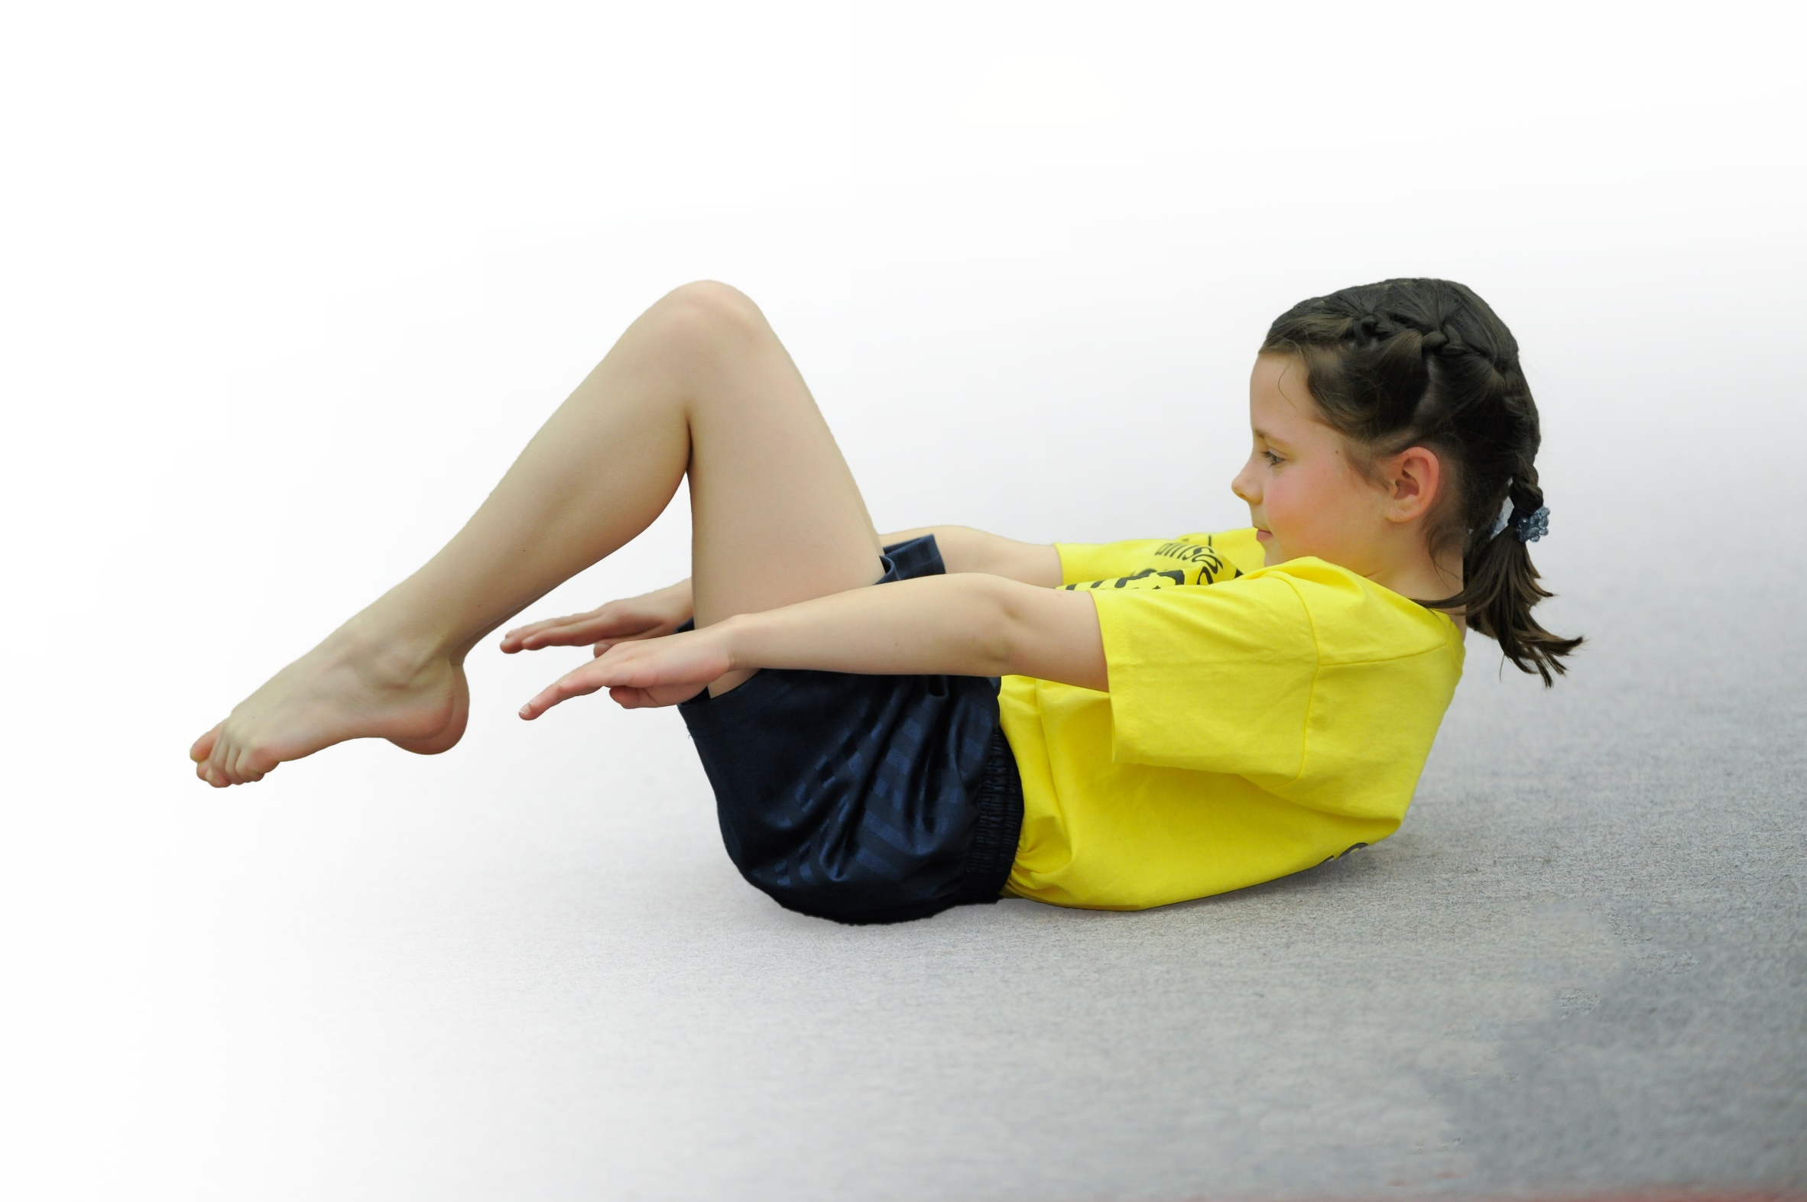
- build capacity and capability within the school to ensure that improvements made now will benefit pupils joining the school in future years

Please visit gov.uk for the revised DfE guidance including the 5 key indicators across which schools should demonstrate an improvement. This document will help you to review your provision and to report your spend. DfE encourages schools to use this template as an effective way of meeting the reporting requirements of the Primary PE and Sport Premium.

We recommend you start by reflecting on the impact of current provision and reviewing the previous spend.
Under the Ofsted Schools Inspection Framework, inspectors will assess how effectively leaders use
the Primary PE and Sport Premium and measure its impact on outcomes for pupils, and how effectively governors hold them to account
for this.

Schools are required to publish details of how they spend this funding as well as on the impact it has on pupils’ PE
and sport participation and attainment.
We recommend regularly updating the table and
publishing it on your website as evidence
of your ongoing review into how you are using the money
to secure maximum, sustainable impact. To see an example of how to complete the table please click HERE.

Support for review and reflection - considering the 5 key indicators from DfE, what development needs are a priority for your setting and your students now and why? Use the space below to reflect on previous spend, identify current need and priorities for the future.

Key achievements to date: | Areas for further improvement and baseline evidence of need:
School Games Silver  Top up swimming sessions introduced for Year 4.  All children have 2 hours timetabled PE sessions a week.  In Summer 2019 66 % of children were involved in extracurricular sporting activities. | Develop Whole School Daily Physical Challenge  For children to reach the Government recommendation of the 60 minutes of daily physical activity. 30 minutes during the school day and encourage and develop opportunities for 30 minutes outside the school day.

Meeting national curriculum requirements for swimming and water safety | Please complete all of the below*:
What percentage of your current Year 6 cohort swim competently, confidently and proficiently over a distance of at least 25 metres? | 52%
What percentage of your current Year 6 cohort use a range of strokes effectively [for example, front crawl, backstroke and breaststroke]? | 52%
What percentage of your current Year 6 cohort perform safe self-rescue in different water-based situations? | 39%
Schools can choose to use the Primary PE and Sport Premium to provide additional provision for swimming but this must be for activity over and above the national curriculum requirements. Have you used it in this way? | Yes.  £2,000 for summer top up weekly sessions for those year 4 and 5 children unable to swim 25meters.
*Schools may wish to provide this information in April, just before the publication deadline.

Action Plan and Budget Tracking
Capture your intended annual spend against the 5 key indicators. Clarify the success criteria and evidence of impact that you intend to measure to evaluate for students today and for the future.

Academic Year: 2019/20 | Total fund allocated: £17,390 | Date Updated: 12th December 2019
Key indicator 1: The engagement of all pupils in regular physical activity – Chief Medical Officer guidelines recommend that primary school children undertake at least 30 minutes of physical activity a day in school |  |  |  | Percentage of total allocation:
 |  |  |  | 10%
School focus with clarity on intended impact on pupils: | Actions to achieve: | Funding allocated: | Evidence and impact: | Sustainability and suggested next steps:
Invest in playtime equipment – whole school  Skip2Bfit day  Whole school daily challenge  Training Sports Crew  Midday training  Active 30 minutes  To raise the profile of physically active learning. | Pupil questionnaires - school council. Audit equipment e.g. bats balls quoits, beanbags.  Relaunch skipping challenge with whole school skipping challenge with Skip2Bfit.  Children to all be involved in daily 2 minutes daily skipping challenge. 2 mins practice and 2 mins timing themselves.  LS to take 8 Year 5 and 6 pupils to West Notts College for Sports crew training provided by School Games (Jan 2020)  Transport to venue  5 MDSAs in spring term trained by Next Level Sport to encourage children to be more active during Lunchtimes.  11.12.19 LS conducted a learning walk to observe physically active lessons/starters across school.  Staff training – Inset day starter on Jan 6th delivered by LS, based on the inclusive PE training from Sportsability.  We will use Maths of the day, Supermovers, Wake and Shake.  To join the Stand up Notts day – this is a no chair day for all children in school. In summer term. | £ 500  £750  £350  £200  £0  £0 | Children more active during break times, playing cooperatively.  More pupils involved in daily skipping. Everybody active, working towards the 30 minutes daily physical activity.  Year 5 and 6 children trained to lead activities. 1 focused activity / challenge a day. LS to train 4 KS1 pupils.  Children are more active at lunchtimes. MDSA engaged with pupils.  All classes to be using age-appropriate physical starters.  All to children will have participated. Staff have a bank of further ideas. | Ks1 and Ks2 playground leaders to initiate activities and playground monitors to check on equipment. Children from Y5 and Y6 to attend sports crew training spring term.  School daily challenge  2+2 minutes skipping every day for every year group.  This will last all year.  Year 5 pupils to continue when Year 6 pupils move onto secondary school.  Continue to monitor MDSA training needs and retrain if necessary.  Monitor/learning walks termly.  Staff to share ideas for best ways for future planning.
Key indicator 2: The profile of PE and sport being raised across the school as a tool for whole school improvement |  |  |  | Percentage of total allocation
 |  |  |  | 1%
School focus with clarity on intended impact on pupils: | Actions to achieve: | Funding allocated: | Evidence and impact: | Sustainability and suggested next steps:
Sport Themed assemblies  Termly newsletter  Termly Governors report  Notice Board  Health and Wellbeing day  Conference  PE policy  Physically active fundraising projects supported by PTFA: sponsored walk and the Joe Wicks challenge for Children in Need.  School Games Mark. | LS PE coordinator to provide sports themed assemblies every half term.  Certificates to celebrate in school sporting achievements used as part of weekly Superkids celebration assembly.  Half-termly school/sports values, e.g. team work, perseverance to be awarded with a PE certificate at the end of each half term. One child per year group.  Sporting Newsletters sent home termly, also posted on  Facebook and Website  PE Coordinator to inform School Governors how the PE premium money is being spent.  Hall notice board showing PE though the school and corridor notice board for events/ competitions/ challenges/ club links.  LS and SM (PE and PHSE coordinators) to arrange a whole school Health and wellbeing day incorporating PHSE and PE.  LS and JF to attend annual conference.  Policy updated by LS.  PTFA sponsor forms and stamp sheets. Advertise them on FB and website. Discuss them in assemblies.  To increase the number of children taking part in after-school clubs. Increase the number of sport leaders. Maintain Silver and attempt Gold. | £0  £10 printing costs  £0  £10  £100  £20  £0  £0  £0 | Celebrating sporting achievements  Raise profile of PE  Ensure parents know the range of sporting activities/ events in school.  Governors aware  PE specialist Governor to be fully informed. Set up meeting with PE coordinator.  Parents/ children to see notice boards  All pupils to have a better understanding/ knowledge of how to stay fit and healthy.  Able to write action plan, access new resources and ideas.  Updated policy accessible to all stakeholders.  Money to go towards playground and towards charities.  School able to show Silver award (and Gold at a later date). More children involved in physical activities. A school that is known in the community for promoting physical activity. | Time tabled assemblies  Certificates for children.  Embed this as practice.  LS PE coordinator to deliver report in FGB  Refresh and update when needed.  Plan a health and wellbeing day yearly  Continue to attend.  Continue to update and amend as necessary.  Annual event.  Continue to promote PE. Continue to invite children to participate and promote PE and physical activity to parents and children.

Key indicator 3: Increased confidence, knowledge and skills of all staff in teaching PE and sport |  |  |  | Percentage of total allocation:
 |  |  |  | 32%
School focus with clarity on intended  impact on pupils: | Actions to achieve: | Funding  allocated: | Evidence and impact: | Sustainability and suggested  next steps:
To be aware of currant initiatives from the government regarding PE Sports Premium allocation.  School Games Partnership membership.  Staff CPD including Sport partnership meetings/ SG training courses/ Collaboration links.  Sports coach deliver lessons and teachers observe.  To carry out Staff PE Skills audit at end of academic year.  To work alongside PE teachers in our collaboration to share good practice. | 25th November 2019  LS and JF (PE coordinator/ Head Teacher attend Sports Conference  Termly meetings.  Tennis course on Jan 9th. Athletics 3rd March. Gov and business manager briefing March 9th in the evening. Tri golf March 25th.  Sports coach to deliver sessions and teachers to observe and make notes.  Staff questionnaire.  Spring term meeting between LS and Adam Newman from Farmilo in spring term. | Partnership membership £500  £500 for 3 days’ cover and 3 courses.  £4,250  £0  £220 | Increased knowledge and confidence all staff.  Staff attending training courses to feed back to staff though Staff meetings and Key stage meeting.  Higher quality PE lessons. The teaching and learning from those lessons should be cascaded down into our curriculum. The sessions by the coaches should have a direct impact upon the quality of PE in school. Lesson plan notes to be monitored by PE coordinator.  Completed questionnaires and long term plan.  Shared good practice and address gaps. | Part of school games partnership offer continue to be a member of the partnership.  Staff and govs to attend and feed back to staff. Teachers to plan lessons based on what they have learned.  The sessions by the coaches should have a sustained impact upon the quality of PE in school.  The skills audit will influence the objectives and coverage on the long term plan.  Continue links.
Key indicator 4: Broader experience of a range of sports and activities offered to all pupils |  |  |  | Percentage of total allocation:
 |  |  |  | 23%
School focus with clarity on intended  impact on pupils: | Actions to achieve: | Funding  allocated: | Evidence and impact: | Sustainability and suggested  next steps:
Additional achievements:  To introduce children to new sports  through in-school coaches as part of PE sessions and after-school clubs.  New equipment to support new sports.  As part of after school offers coaches and staff used to run after school clubs. | Long term plan used to introduce new sports which can be delivered by coaches or class teachers depending on need.  In school coaches to be used to deliver a 6 week block of lessons for the following sports  Ti-chi, dance, dodge ball, handball, gymnastics and athletics.  Staff to deliver new sports to the children using knowledge learned from previous coaches, and using personal strengths e.g. KS’s netball teaching and LW’s badminton.  Audit equipment in line with long term plan .  Refresh old broken equipment.  Coaches booked for after school sessions.  After-school clubs to include  rugby, body combat, handball, dance, football, multi skills 5/60 club, Boccia, | £3,000 for after-school clubs.  £1,000 | Staff able to create own lesson plans following coach sessions.  Children introduced to new sports and out of school club links.  Club flyers, posters distributed news on newsletter, webpage and face book for links.  Staff use knowledge gained from previous coach sessions and strengths to plan and deliver lessons. Lesson plans audit.  Club links developed for children to take up sports outside of school  Children have the correct and safe equipment during PE sessions  More children involved in afterschool activity contributing to the 60 active minutes.  Club links developed for children to take up sports outside of school | Staff questionnaires to address gaps for future planning.  Because funding may end at the end of this academic year, teachers need to make the most of these opportunities and make sustainable plans for the future.  Continue to audit and monitor  Funding dependent for 2020-21.
Key indicator 5: Increased participation in competitive sport |  |  |  | Percentage of total allocation:
 |  |  |  | 12%
School focus with clarity on intended  impact on pupils: | Actions to achieve: | Funding  allocated: | Evidence and impact: | Sustainability and suggested  next steps:
All children to be involved in competitive games/ competition.  To develop school Intra games  For pupils to represent the school in competitive games.  All children to take part in individual challenge  Traditional sports day  All children to take part in Mini Olympics day to tie in with the Tokyo Olympics 2020.  Sports relief event – personal best challenge. | Following a block of PE lesson coach sessions, children to take part in house competitions between year groups.  Events to include football, dodgeball, handball and rounders.  Children selected depending on SG criteria to represent the school in a variety of sporting events.  Annual Intake sports day  Sports Crew to develop skills by being leaders  Year 6 to act as leaders.  All children to be involved in a competition/challenge, competing against themselves. Sports leaders to help to run it. | £ 0  (part of the indicator 4 funding)  Transport costs  £1,500  2 TAs paid for 6 events after-school = £255.  £10 for reward stickers.  £10 for reward stickers.  £10 for reward stickers. | Improved standards of competitive games. All key stage 1 and 2 children to be involved in at least one in-house competitive competition.  Events and results reported on notice board web page and newsletter and Facebook.  All children take part efforts and involvement rewarded.  Parents invited to Traditional Sports day to support pupils. | Continue to include Intra as part of the PE sessions following a block of work.  Intra can be maintained as no cost.  Staffing and costing implications for 2020-21 budget  Low cost can be maintained forms part of school annual events.

Additional Information Swimming
 |  |  |  | Percentage of spend 24%
School Focus with clarity on intended pupils Impact | Action to achieve | Funding allocation | Evidence and impact | Sustainability  Next steps
For all pupils to be able to swim 25 metres by the end of Year 6 using a range of strokes and to perform a safe self-rescue. | Weekly continuous swim booster sessions all year for Year 4 pupils. | £4,195 | The percentage of children being able to swim 25 meters will rise from its current figure of 52%. | Sustainability is dependent upon the funding 2020-2021.

