

2020-2021
Schools must use the funding to make additional and sustainable improvements to the quality of PE and sport they offer. This means that you should use the Primary PE and Sport Premium to:

- develop or add to the PE and sport activities that your school already offers
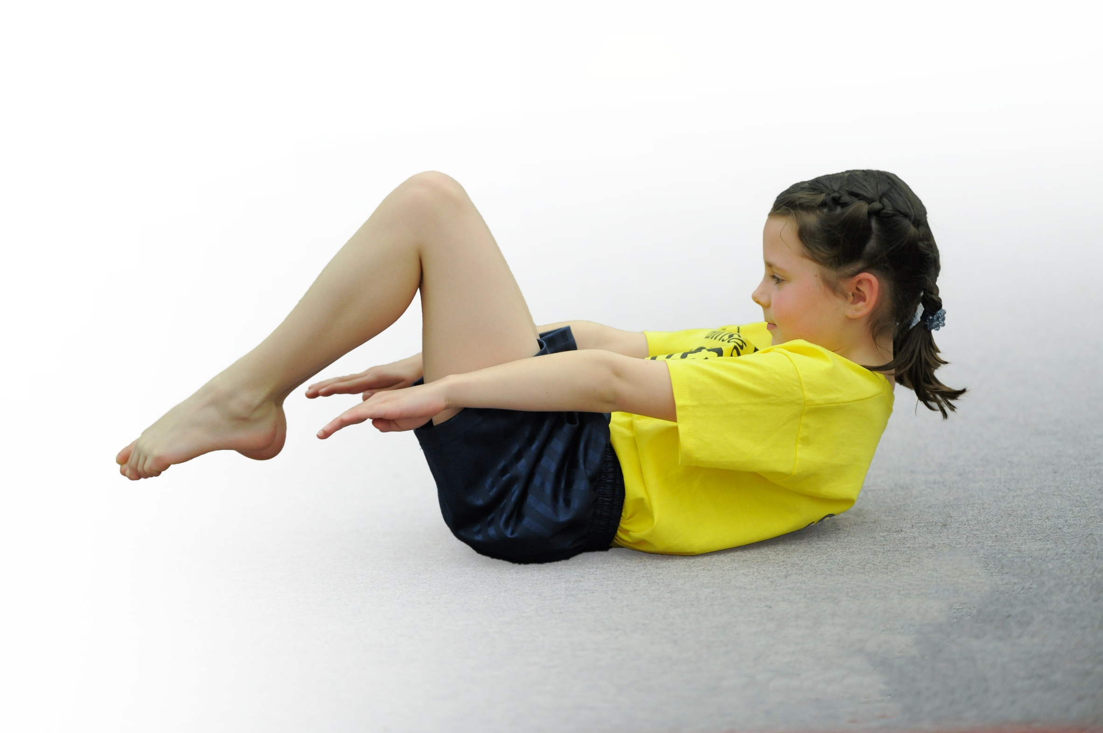
- build capacity and capability within the school to ensure that improvements made now will benefit pupils joining the school in future years

Please visit gov.uk for the revised DfE guidance including the 5 key indicators across which schools should demonstrate an improvement. This document will help you to review your provision and to report your spend. DfE encourages schools to use this template as an effective way of meeting the reporting requirements of the Primary PE and Sport Premium.

We recommend you start by reflecting on the impact of current provision and reviewing the previous spend.
Under the Ofsted Schools Inspection Framework, inspectors will assess how effectively leaders use
the Primary PE and Sport Premium and measure its impact on outcomes for pupils, and how effectively governors hold them to account
for this.

Schools are required to publish details of how they spend this funding as well as on the impact it has on pupils’ PE
and sport participation and attainment.
We recommend regularly updating the table and
publishing it on your website as evidence
of your ongoing review into how you are using the money
to secure maximum, sustainable impact. To see an example of how to complete the table please click HERE.

Support for review and reflection - considering the 5 key indicators from DfE, what development needs are a priority for your setting and your students now and why? Use the space below to reflect on previous spend, identify current need and priorities for the future.

Key achievements to date: | Areas for further improvement and baseline evidence of need:
School Games Silver – maintained  Top up swimming sessions introduced for Year 4.  All children have 2 hours timetabled PE sessions a week.  During Covid lockdown, children in school were provided with 2 hours of high quality weekly PE sessions. And 60 minutes daily physical activity. | Develop Whole School Daily Physical Challenge  For children to reach the Government recommendation of the 60 minutes of daily physical activity. 30 minutes during the school day and encourage and develop opportunities for 30 minutes outside the school day.  Focusing on lunchtime, we aim to increase physical activity during lunchtime.  To contribute to the children’s mental health and wellbeing (as part of the school’s catch-up recovery curriculum.)  Develop opportunities to have 30 minutes’ physical activity outside the school day.

Meeting national curriculum requirements for swimming and water safety | Please complete all of the below*:
What percentage of your current Year 6 cohort swim competently, confidently and proficiently over a distance of at least 25 metres?
What percentage of your current Year 6 cohort use a range of strokes effectively [for example, front crawl, backstroke and breaststroke]?
What percentage of your current Year 6 cohort perform safe self-rescue in different water-based situations?
Schools can choose to use the Primary PE and Sport Premium to provide additional provision for swimming but this must be for activity over and above the national curriculum requirements. Have you used it in this way? | Yes.  £2,000 for top up weekly sessions for all year 4 children.  This is booked in, but we have not been able to access it due to Covid restrictions.
*Schools may wish to provide this information in April, just before the publication deadline.

Action Plan and Budget Tracking
Capture your intended annual spend against the 5 key indicators. Clarify the success criteria and evidence of impact that you intend to measure to evaluate for students today and for the future.

Academic Year: 2020-21 | Total fund allocated: £22,069 | Date Updated: 2nd December 2020
Key indicator 1: The engagement of all pupils in regular physical activity – Chief Medical Officer guidelines recommend that primary school children undertake at least 30 minutes of physical activity a day in school |  |  |  | Percentage of total allocation:
 |  |  |  | 10%
School focus with clarity on intended impact on pupils: | Actions to achieve: | Funding allocated: | Evidence and impact: | Sustainability and suggested next steps:
Invest in lunchtime and playtime equipment – whole school  Relaunch Skip2Bfit skipping challenge Spring 1  Whole school weekly challenge  Training Sports Crew  Midday training  Active 30 minutes  To raise the profile of physically active learning. | Pupil questionnaires - school council. Audit equipment e.g. bats, balls, quoits, beanbags.  Relaunch skipping challenge with whole school skipping challenge with Skip2Bfit.  Children to all be involved in 2 minutes daily skipping challenge. 2 mins practice and 2 mins timing themselves.  Next level to train KS2 play leaders within the bubbles.  4 MDSAs in spring term trained by Next Level Sports (who will come in one afternoon) to encourage children to be more active during lunchtimes, improve physical activity and behaviour.  Learning walk (week beginning 07.12.20 during afternoons).  LS to observe physically active lessons/starters across school.  Staff training – Inset day starter on Jan 4th to be delivered by LS, showing some good examples of physically active lesson starters or plenaries. E.g. phonics activities, Maths of the day, Supermovers, Wake and Shake.  To join the Stand up Notts day – this is a no chair day for all children in school. In autumn term. | £2,000 for playtime  and  £2,000 for lunchtime  £0  £100 for Pip to come in extra  £0?  £0  £0 | Children more active during break times and lunchtimes, playing cooperatively improve cooperation, improve behaviour, improve gross and fine motor skills. KS2 to develop leadership skills and perseverance skills.  More pupils involved in skipping. Everybody active.  Celebratory assembly every half term.  KS2 children trained to lead activities. 1 focused activity / challenge a day.  Children are more active at lunchtimes. Improved behaviour. MDSA engaged with pupils.  All classes to be using age-appropriate physical starters.  All to children will have participated. Staff have a bank of further ideas. | Ks1 and Ks2 playground leaders to initiate activities and playground monitors to check on equipment. Activity/challenge bags to be set up and used in the future.  Mini leaders to be trained in each bubble in KS2. Pip to train them.  School weekly challenge  School skipping challenge.  This will last all year.  This will help to build up the number of trained pupils.  Continue to monitor MDSA training needs and retrain if necessary.  Monitor/learning walks termly.  Staff to share ideas for best ways for future planning.
Key indicator 2: The profile of PE and sport being raised across the school as a tool for whole school improvement |  |  |  | Percentage of total allocation
 |  |  |  | 1%
School focus with clarity on intended impact on pupils: | Actions to achieve: | Funding allocated: | Evidence and impact: | Sustainability and suggested next steps:
Sport Themed assemblies  Termly newsletter  Termly Governors report  Notice Board  Health and Wellbeing day  Conference (if it happens – Covid restrictions)  PE policy  Physically active fundraising projects supported by PTFA: sponsored walk and the Joe Wicks challenge for Children in Need. We will do this in a Covid-friendly way.  School Games Mark. (Due to Covid restrictions, we can’t get this this year. We will have complete a self-evaluation form and send it in.) | LS PE coordinator to provide sports themed assemblies every half term.  Certificates to celebrate in school sporting achievements used as part of weekly Superkids celebration assembly.  Half-termly school/sports values, e.g. team work, perseverance to be awarded with a PE certificate at the end of each half term. One child per year group.  Sporting Newsletters sent home termly, also posted on  Facebook and Website  PE Coordinator to inform School Governors how the PE premium money is being spent.  Hall notice board showing PE through the school and corridor notice board for events/ competitions/ challenges/ club links.  LS and EW and LL (PE and PHSE coordinators and school liaison officer) to arrange a whole school Health and wellbeing day incorporating PHSE and PE.  LS and JF to attend annual conference.  Policy updated by LS.  PTFA sponsor forms and stamp sheets. Advertise them on FB and website. Discuss them in assemblies.  To increase the number of children taking part in after-school clubs. Increase the number of sport leaders. Maintain Silver and attempt Gold. | £0  £10 printing costs  £0  £10  £100  £20  £0  £0  £0 | Celebrating sporting achievements  Raise profile of PE.  Ensure parents know the range of sporting activities/ events in school.  Governors aware  PE specialist Governor to be fully informed. Set up meetings with PE coordinator.  Parents/children to see notice boards  All pupils to have a better understanding/ knowledge of how to stay fit and healthy.  Able to write action plan, access new resources and ideas.  Updated policy accessible to all stakeholders.  Money to go towards playground and towards charities.  School able to show Silver award (and Gold at a later date). More children involved in physical activities. A school that is known in the community for promoting physical activity. | Time tabled assemblies  Certificates for children.  Embed this as practice.  LS PE coordinator to deliver report in FGB meeting.  Refresh and update when needed.  Plan a health and wellbeing day yearly  Continue to attend.  Continue to update and amend as necessary.  Annual event.  Continue to promote PE. Continue to invite children to participate and promote PE and physical activity to parents and children.

Key indicator 3: Increased confidence, knowledge and skills of all staff in teaching PE and sport |  |  |  | Percentage of total allocation:
 |  |  |  | 32%
School focus with clarity on intended  impact on pupils: | Actions to achieve: | Funding  allocated: | Evidence and impact: | Sustainability and suggested  next steps:
To be aware of current initiatives from the government regarding PE Sports Premium allocation – and government guidelines for Covid PE guidance.  School Games Partnership membership.  Staff CPD including Sport partnership meetings/ SG training courses/ Collaboration links.  Sports coaches deliver lessons and teachers observe.  To carry out Staff PE skills audit at end of academic year.  To work alongside PE teachers in our collaboration to share good practice.  LS to provide staff training in Inset days and staff meetings – providing best practice in active learning. Feedback after courses and conference.  To access any NQT PE training on offer. | Continue membership of Mansfield School Games – Nicky Biggs  Contact with Next Level  PE coordinator/ Head Teacher attend Sports Conference if this is organised for 2021.  Termly meetings – LS to access online training provided.  At the moment only the online coordinator is on offer. We will access further training as and it’s offered.  Sports coaches to deliver sessions and teachers to observe and make notes.  Staff questionnaire.  Spring term Teams meeting between LS and Adam Newman from Farmilo.  Inset day 4th Jan starter based on findings from learning walk next week.  Access training. | Partnership membership £500  £500 for 3 days’ cover and 3 courses.  £200 for MDSA training  £5,000  £500 for three days’ cover over the year.  £220  £0  £100 | Increased knowledge and confidence all staff.  Staff attending training courses to feed back to staff though Staff meetings and Key stage meetings.  Higher quality PE lessons. The teaching and learning from those lessons should be cascaded down into our curriculum. The sessions by the coaches should have a direct impact upon the quality of PE in school. Lesson plan notes to be monitored by PE coordinator.  Higher quality PE lessons. Lesson plans from the sessions.  Completed questionnaire which will help to inform the long term plan and support where support is needed.  Shared good practice and address gaps.  High quality PE as a result of LS training.  High quality PE lessons | Part of school games partnership offer - continue to be a member of the partnership.  Continue to be aware of current Government guidelines.  Staff to attend and feed back to staff. Teachers to plan lessons based on what they have learned.  The sessions by the coaches should have a sustained impact upon the quality of PE in school.  Ongoing. Ensure this is completed every year.  The skills audit will influence the objectives and coverage on the long term plan.  Continue links.  LS to observe PE in school to ascertain impact of her training  Increased knowledge and skills.
Key indicator 4: Broader experience of a range of sports and activities offered to all pupils |  |  |  | Percentage of total allocation:
 |  |  |  | 23%
School focus with clarity on intended  impact on pupils: | Actions to achieve: | Funding  allocated: | Evidence and impact: | Sustainability and suggested  next steps:
Additional achievements:  To introduce children to new sports  through in-school coaches as part of PE sessions and after-school clubs.  New equipment to support new sports.  As part of after-school offers, coaches and staff are used to run after school clubs. | Long term plan used to introduce new sports which can be delivered by coaches or class teachers depending on need.  In school coaches to be used to deliver a 6 week block of lessons for the following sports  Athletics, gymnastics, dance, rugby, tri-golf.  Staff to deliver new sports to the children using knowledge learned from previous coaches, and using personal strengths e.g. KS’s netball teaching and LW’s badminton.  Audit equipment in line with long term plan.  Refresh old broken equipment.  Coaches booked for after school sessions.  After-school clubs to include  rugby, multi-skills, Change for Life, Boccia, dance, body combat, football. | See above.  £5,000  £3,000 for after-school clubs.  £2,200 for TAs to do 1st aid and safeguarding | Staff able to create own lesson plans following coach sessions.  Children introduced to new sports and out of school club links.  Club flyers, posters distributed news on newsletter, webpage and Facebook for links.  Staff use knowledge gained from previous coach sessions and strengths to plan and deliver lessons. Lesson plans audit.  Club links developed for children to take up sports outside of school  Children have the correct and safe equipment during PE sessions  More children involved in afterschool activity contributing to the 60 active minutes.  Club links developed for children to take up sports outside of school  Vulnerable children and children with additional needs and less active children are targeted in order for them to access high quality physical sports/activities. | Staff questionnaires to address gaps for future planning.  Because funding may end at the end of this academic year, teachers need to make the most of these opportunities and make sustainable plans for the future.  Continue to audit and monitor  Funding-dependent for 2021-22.
Key indicator 5: Increased participation in competitive sport |  |  |  | Percentage of total allocation:
 |  |  |  | 12%
School focus with clarity on intended  impact on pupils: | Actions to achieve: | Funding  allocated: | Evidence and impact: | Sustainability and suggested  next steps:
All children to be involved in competitive games/competitions.  To develop school Intra games.  Due to Covid, we are entering more virtual games.  For pupils to represent the school in competitive games if this is restarted.  All children to take part in Traditional sports day  All children to take part in Mini Olympics day or round robin sports event in summer term.  Sports fund raising event in spring term – personal best challenge. | Following a block of PE lesson coach sessions, children to take part in competitions within their bubbles.  Events to include athletics, striking and fielding, dodgeball and rounders.  After-school clubs to have a competitive element and inter-competitions.  Children selected depending on School Games criteria to represent the school in a variety of sporting events.  Annual Intake sports day  Sports Crew to develop skills by being leaders  Sports crew leaders to work at the event.  All children to be involved in a competition/challenge, competing against themselves. Sports leaders to help to run it. | £0  (part of the indicator 4 funding)  Transport costs  £1,500  2 TAs paid for 6 events after-school = £255.  £10 for reward stickers.  £10 for reward stickers.  £10 for reward stickers. | Improved standards of competitive games. All key stage 1 and 2 children to be involved in at least one in-house competitive competition.  Events and results reported on noticeboard web page and newsletter and Facebook.  All children take part; efforts and involvement rewarded.  Parents invited to Traditional Sports day to support pupils if this happens in the summer term. | Continue to include Intra as part of the PE sessions following a block of work.  Intra can be maintained at no cost.  Staffing and costing implications for 2021-22 budget  Low cost can be maintained forms part of school annual events.

Additional Information Swimming
 |  |  |  | Percentage of spend 24%
School Focus with clarity on intended pupils Impact | Action to achieve | Funding allocation | Evidence and impact | Sustainability  Next steps
For all pupils to be able to swim 25 metres by the end of Year 6 using a range of strokes and to perform a safe self-rescue. | Weekly continuous swim booster sessions all year for Year 4 pupils. | £4,195 | The percentage of children being able to swim 25 meters will rise from its current figure of 52%. | Sustainability is dependent upon the funding 2021-2022.

