All children requite support in uncertain times and we are certainly facing that now with the spread of the coronavirus (COVID- 19). Having to cope with sudden changes, school closures and changes in routines without the support and connections with teachers and friends affects us all. Individuals with Autism may need addition support to process the news and adapt to the many changes. The following support strategies are to help support and can be adapted to the varied needs of individual children.

Individuals with autism may have a varied level of understanding about COVID – 19 virus, how it spreads and how to reduce the risk of infection. It is important to keep the information clear and use the correct terms, avoid using flowery language or abstract phrases, such as ‘she is a little under the weather’. Using direct and clear language is recommended.

A social story can help to clarify information. There are many different examples available, reading the stories regularly and I would suggest to revisit and adjust as needed as circumstances change.
Provide visual support to offer guidance. Have ‘rules’ on how we greet people, even in our own family, social distancing and hand washing.
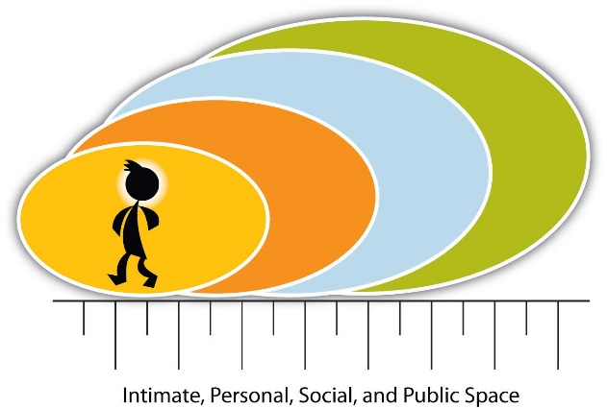




For individuals with autism, these communication difficulties may be coupled with expressive communication delays, limited verbal or nonverbal skills, difficulty perspective taking, and/or social communication deficits. Giving each individual the opportunity to express themselves as individuals is essential. This can be done through family and individual discussions, writing activities, movie making, or play.


Coping and calming skills are a priority in these uncertain times. These may include rocking in a rocking chair, listening to music on headphones, deep breathing, watching a preferred film, exercise, or accessing a favourite activity or material. If coping or calming strategies are not yet part of the routine, caregivers can prioritize the teaching of these skills during this time of uncertainty. Create a concrete and visual routine to support the use of these strategies. There are plenty of free apps available such as Headspace or Calm.


Coping/calming activities may be scheduled regularly across the day in the initial weeks of changes, then, if appropriate, caregivers may introduce and teach a self-management plan that helps individuals track their anxious or worried responses and identify when the calming strategies are required. Exercise/physical activity is a proven strategy to reduce anxiety symptoms with the broader population, as well as with individuals with autism. Consider establishing or adding basic exercise routines for the family such morning PE sessions or wearing a Fitbit.



While it is important to create time and space for all family members to process uncertainty, individuals with autism may cope best when daily routines are only minimally interrupted. Important routines to maintain include:

Sleep/wake routines:
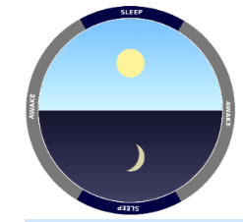
Maintaining physical health is key for all family members and ensuring proper sleep is an important contributor. Sleep disturbances are more common in individuals with autism, thus extra attention may be required to support good sleep hygiene and maintain bedtime and waking routines.
https://www.autismspeaks.org/sleep.

Household tasks/daily living skills:

Taking part in structured household routines is a recommended strategy to support children and young adults coping with stress related to COVID-19.
Expanding the use of a visual schedule, and using one more regularly throughout the day, may help facilitate participation in activities at home and reduce anxiety. The format and length of the schedule may vary based on the individual’s needs, I have included a few examples.

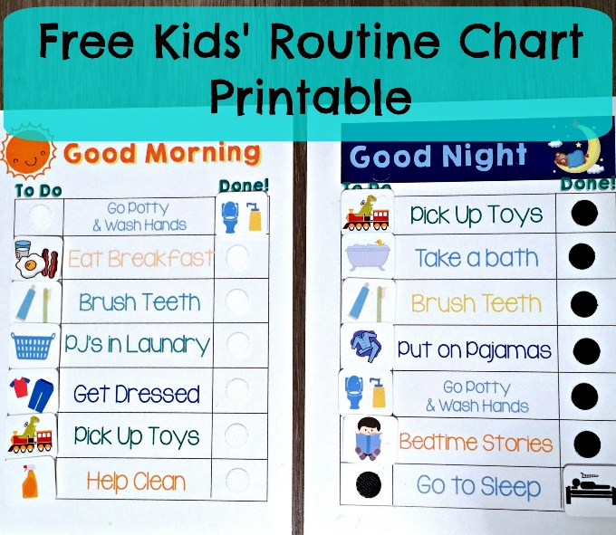
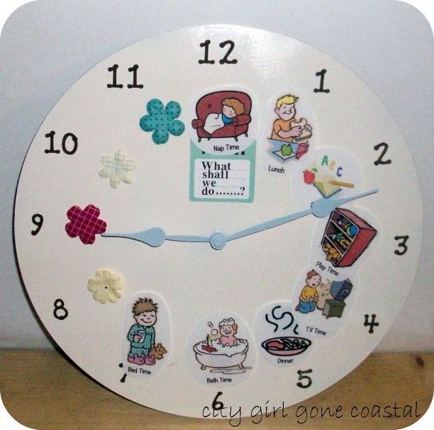


It may also be necessary to create new routines during this time, as there are many new demands of caregivers—home-schooling for the first time, continuing to work in/out of the home, and/or caring for multiple children or other family members.
Electronic devices:

Children and young adults may access screens more often and for longer periods of the day during this time. Transitioning away from a device, especially after a period of extended use, may be difficult for many children and young adults; however, the behavioural rigidity and inflexibility often characteristic in individuals with autism may make these transitions problematic. Establishing a clear, consistent, and concrete routine for this transition can better prepare the individual for the coming transition and offer support throughout.
Use a visual timer:
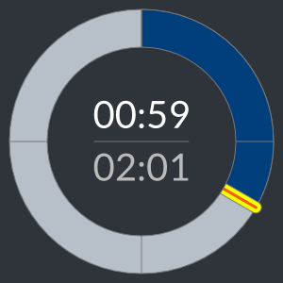
It may be helpful for individuals with autism to “see” how much time remains of screen time before they will be expected to transition to off the device. Concepts related to time are fairly abstract (e.g. “You have a few minutes”), often cannot be interpreted literally e.g. “Just a second”, and may be confusing, especially if time-telling is not a mastered skill. Presenting information related to time visually can assist in making the concepts more meaningful. An online stopwatch can help.
This Photo by Unknown Author is licensed under CC BY
https://www.online-stopwatch.com/
It is worth noting that this is an individual preference and timers can be a source of anxiety. Another visual transition strategy to use is a visual countdown system. Like the visual timer, a visual countdown allows an individual to “see” how much time is remaining in an activity.
This tool is beneficial if the timing of the transition needs to be flexible (e.g. caregiver would like the child to stay engaged on the device during a cooking the dinner. This could come in the for of coloured post-its. The caregiver would remove the post-its evenly and when the last post-it note is gone they must stop.
Offer choices:
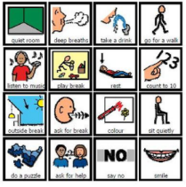
In a time of crisis, when most people feel like so much is out of their control, providing choices can increase a sense of autonomy and motivation. Creating regular opportunities across the day where family members have a voice about what happens and when it happens can serve as an effective anxiety reducing strategy and a communication tool.
These choices might include meal choices or activities they wish to complete that day. It is worth noting, do not offer too many choices and always offer a choice in a calm period to avoid over- stimulation.

Create a workspace with a to-do list.
This will be the first time many children and young adults will be expected to complete schoolwork in the home setting. Individuals with autism may have difficulty generalizing the strategies and skills they used in the school environment to the home environment (e.g. organising materials, attending to work activities, submitting assignments online). Thus, it will be helpful to set up a designated workspace to help clarify expectations and reduce distractions. This may be a spot at the dining room table designated by their books and facing away from the television or window. If multiple children are working in one space, consider adding a small visual divider (e.g. an open folder) between them. It is important they still have a schedule as they do in school.
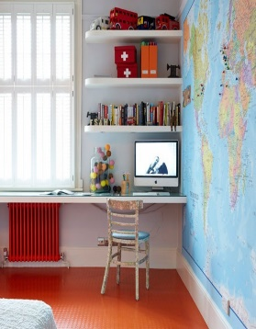


Individuals with autism can find social isolation a very difficult concept, and this may be worsened by quarantine conditions. Positive social support is important for everyone during this period, and individuals with autism may need more explicit facilitation to ensure that social connections continue. Caregivers may need to check in to ensure social contact is continuing via text or direct messaging, and/or build in opportunities for daily social contact with family, friends, or others via FaceTime, What’s App, Google Hangout, or other apps.

Change in behaviours

Caregivers should be aware of the behaviour of individuals with autism during these uncertain times and be alert for signs of anxiety and depression. These may include a change in sleeping or eating patterns, increases in repetitive behaviours, excessive worry, increased agitation or irritability. The individual may require more support or different types of support (e.g., regular therapy, regular exercise, medication).

Above all remain safe in these worrying times.

